Free School Visits with Ely Wildspace
Are you looking for a way of enriching the curriculum in history, geography or science?
Do you want to spark an interest which may last a lifetime?
If the answer is yes to any of these questions, a free visit within Ely led by volunteers from Ely Wildspace could be the answer.
Amongst Ely Wildspace volunteers are a number of enthusiastic naturalists and former teachers who are willing and able to give groups of school children a first-hand knowledge of the area and a hands on investigation of the wildlife supporting work on habitats. They are also able to work with teachers to create a tailor made visit exploring other areas of the curriculum including local history, physical and economic geography, english, maths and art.
In previous years, groups from Ely St John’s and the Lantern school have visited as part of their science work on habitats. They have explored the area with an enthusiastic guide, and used sweep nets to find insects in a meadow and the wide range of invertebrates on and under the different trees in Pocket Park and used the area for inspiration for art.
Volunteers from Ely Wildspace can also provide assemblies in school and are happy to meet individuals or groups of teachers to discuss possibilities.
Visits are free of charge. For further details contact Helen Moore 01353 664745 or e-mail helen@moorehse.co.uk .
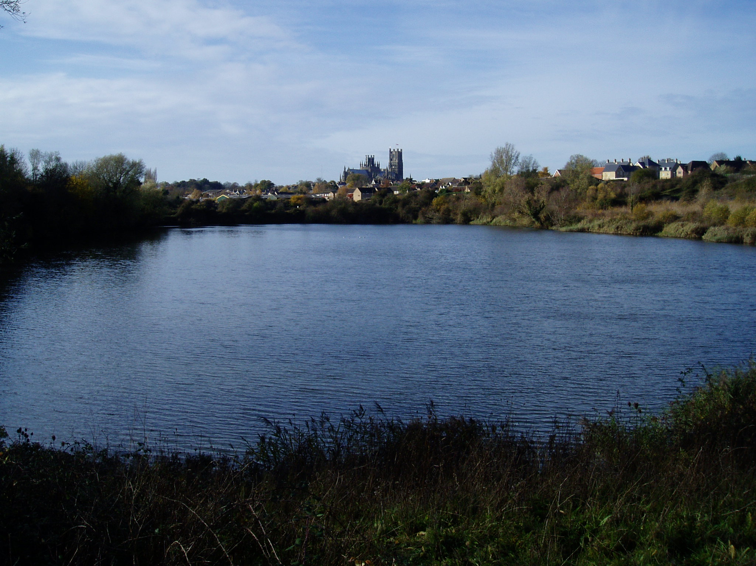
Ely from Kiln Lane

